YAMOTO WEBSITE

SECTION I

Hero banner 1
Visual: A car on a lift with its wheels removed, a technician at work. Use one of the photos from image bank
Headline: Wheel Alignment & Tyre Care in Narsingi, Hyderabad
Button: Book Appointment (the button should lead to making a call, Phone no - +91 96528 07626)
Hero Banner 2
Visual - Tyres lined up
Copy -
HL - Swap your old tyres and Save up to ₹1,000
SH - Buy 4 new tyres and get up to ₹1,000 off
Button - Claim the Offer (should lead to appointment box)
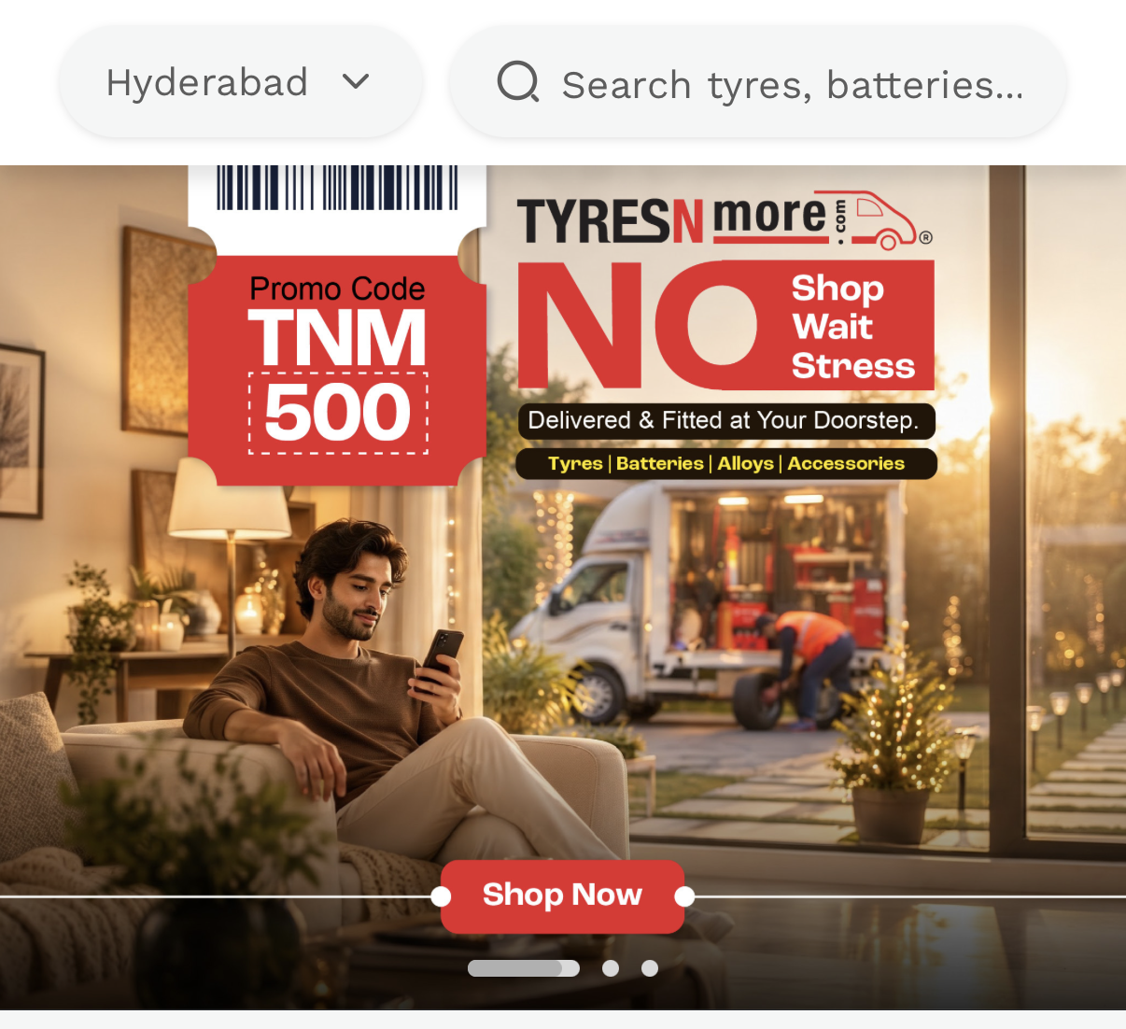
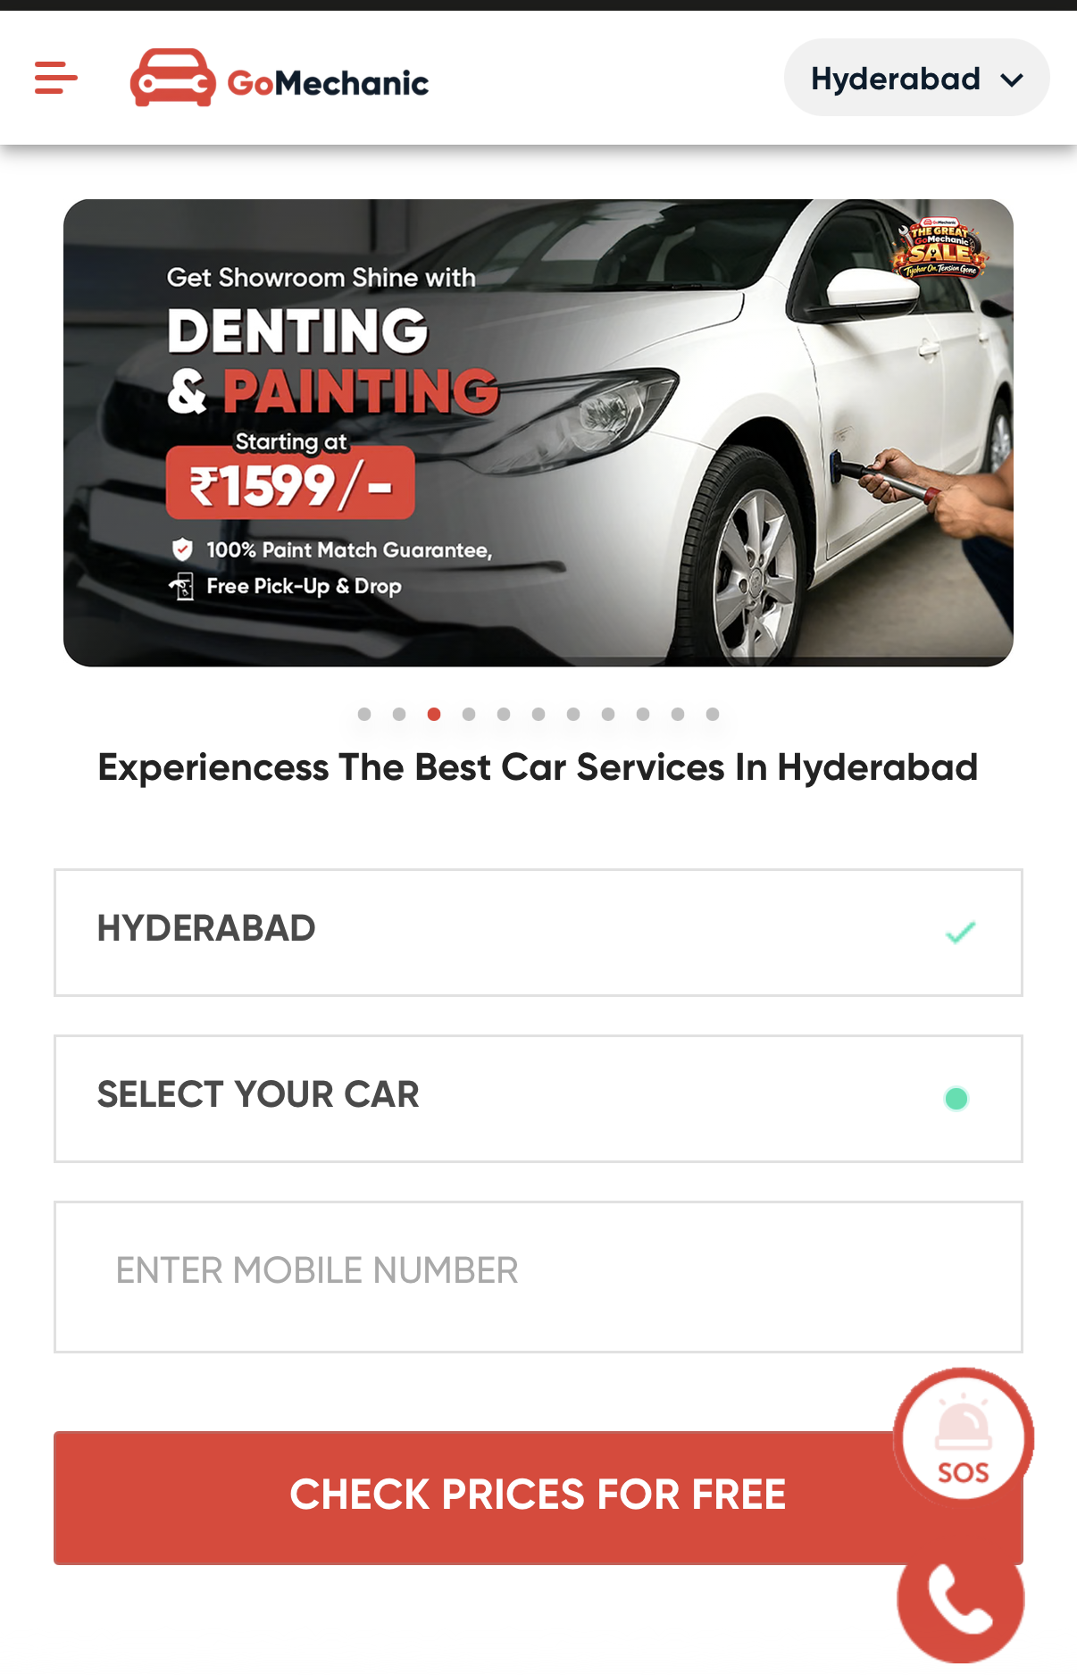
SECTION II

Request-for-quotation box
HL - Get a Free Quote
Fields
- Name
- Mobile number
- Car make and model
- What service do you need? (dropdown option)
- Preferred visit time (optional)

SECTION III

HL - Our Tyre & Wheel Services in Narsingi

Ref -
(create boxes for each service and in it put the copy and visual)

- Wheel alignment
- Wheel balancing
- Tyre rotation
- New tyre replacement
(all these boxes should be clickable and lead to book an appointment box)

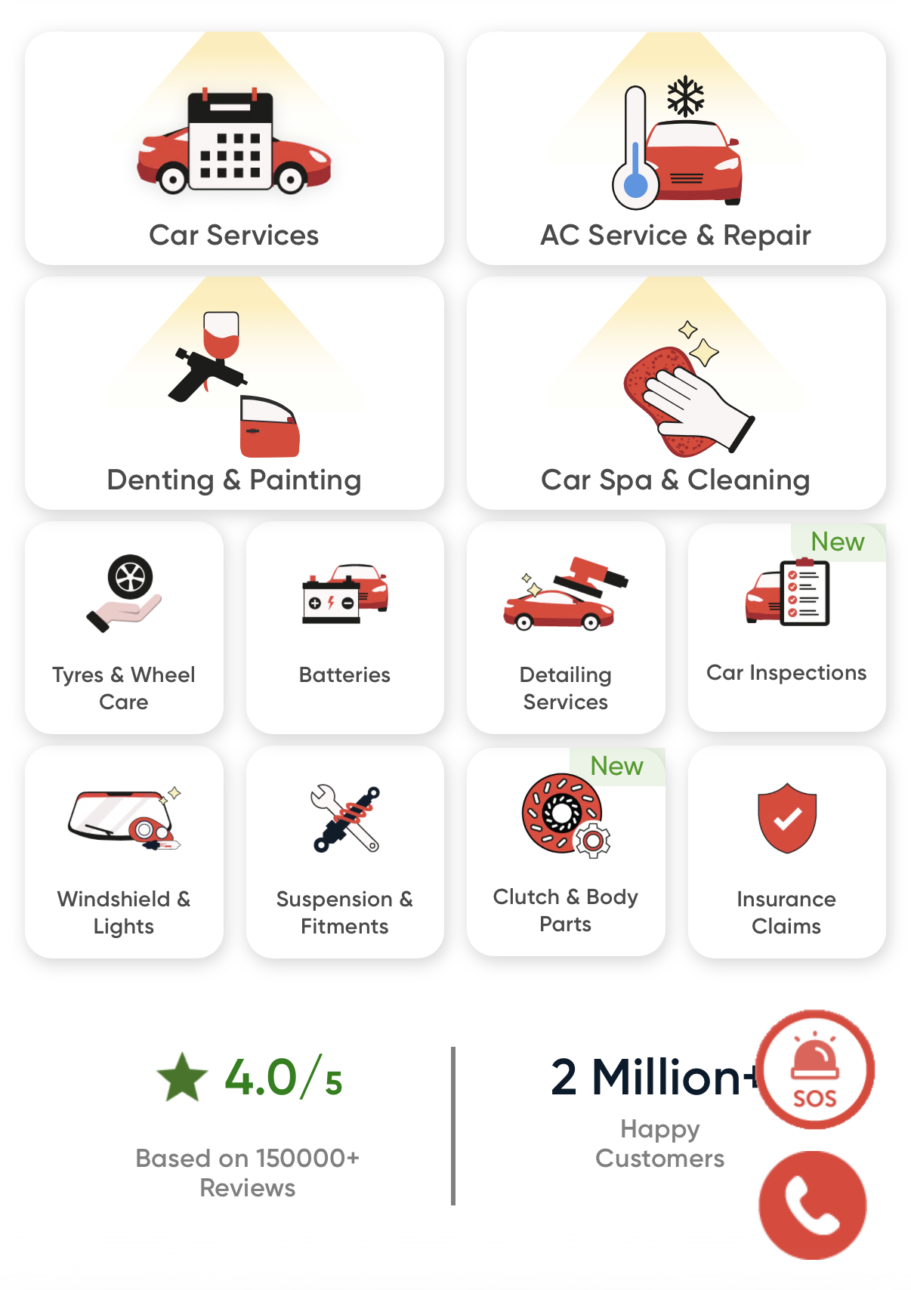

SECTION IV - Location

HL - Visit Yamoto in Narsingi
- Address - Narsingi, Hyderabad, Telangana 500089
Beside HPCL Petrol Station and Bajaj Electronics.
- Opening hours -
  - Monday–Saturday: 10:00 AM – 9:00 PM
  - Sunday: 10:00 AM – 3:00 PM
- Call and WhatsApp buttons
  - (WhatsApp on +91 96760 65353
  - Calls on +91 96528 07626 (8am-8pm)

- Google Maps embed
- Button: Get directions (opens Google Maps)

SECTION V

HL - Why Drivers in Narsingi Trust Yamoto

Ref - 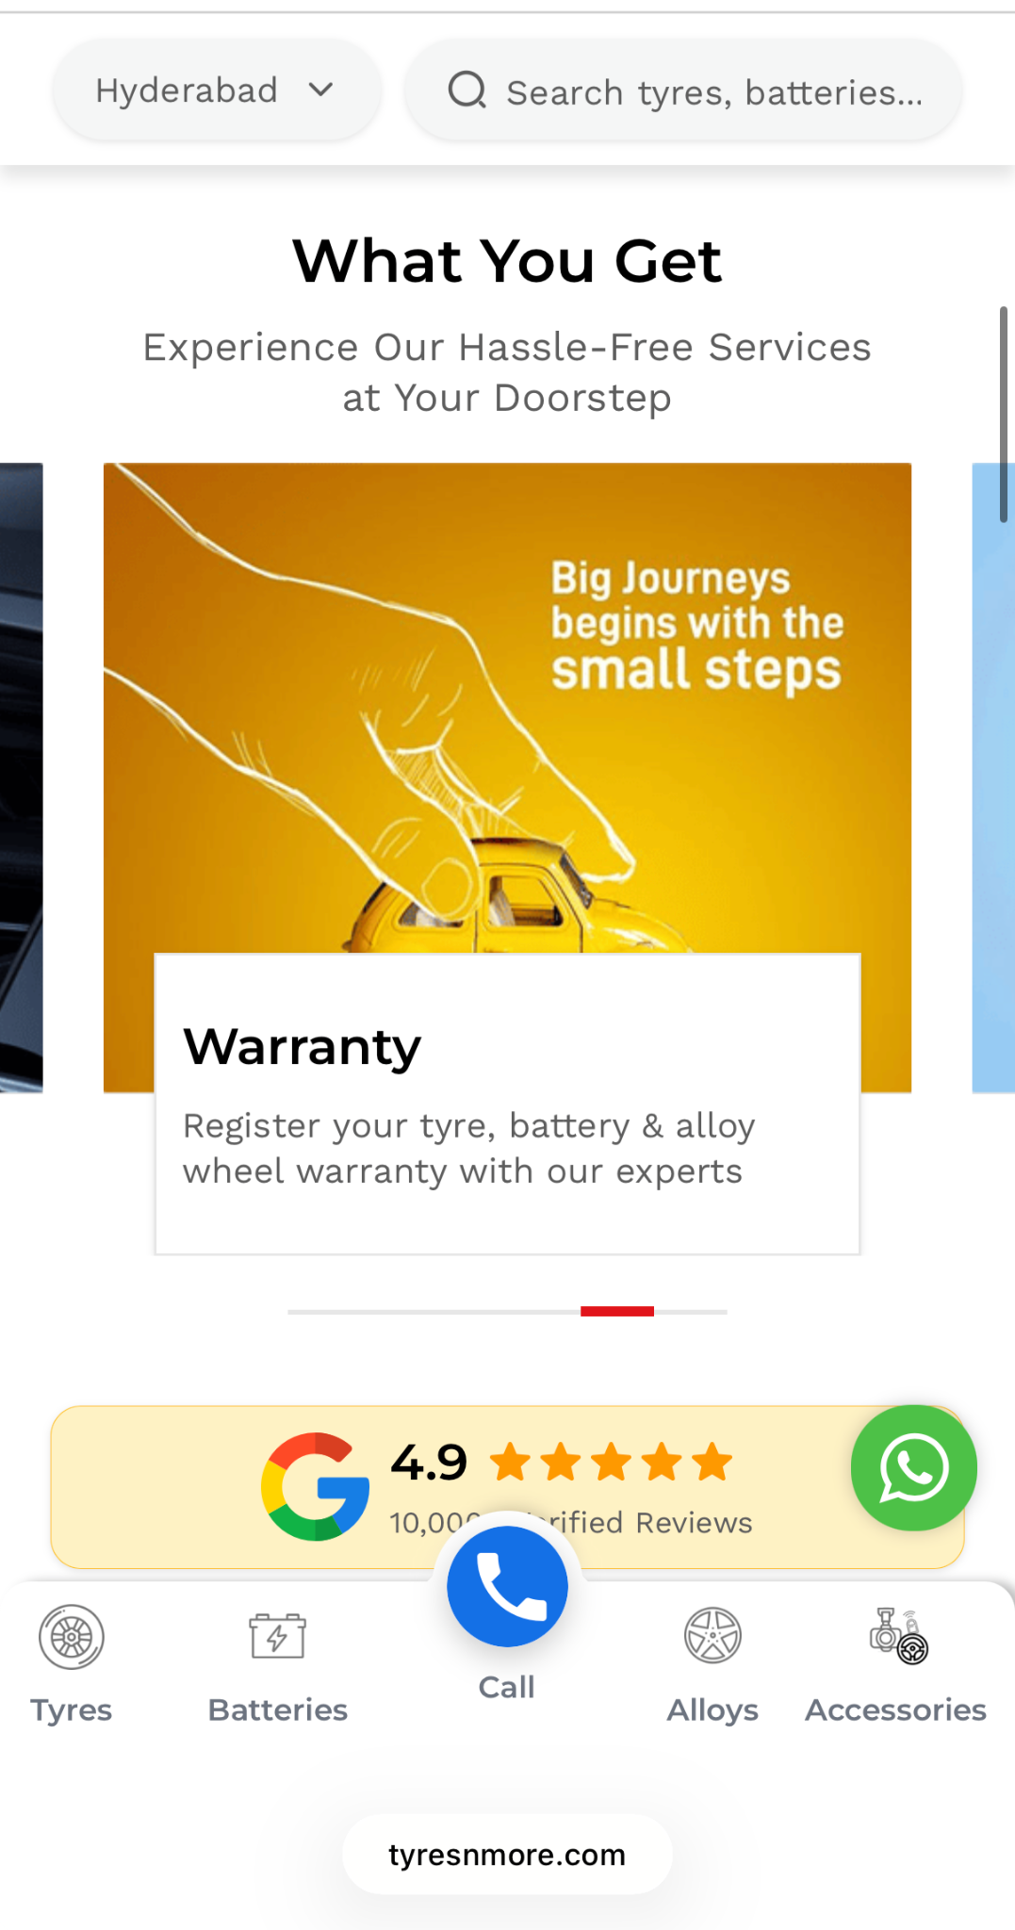

- Value for money - Fair prices with no unnecessary upselling
- Dealers of top tyre brands - From MRF to Michelin, we stock the brands drivers trust
- Precision equipment from ATS Elgi - Our machines come from ATS Elgi, a name known for accuracy. This leads to more precise alignment and balance

SECTION VI - Brand Panel

HL - Choose from India’s Leading Tyre Brands
- MRF
- Bridgestone
- Apolllo
- JK Tyre
- Continental
- Michelin
- Ceat
- Yokohama
- Goodyear

SECTION VII
HL - What Our Customers Say
Structure: 3 review cards, each with star rating, short quote, customer first name and the car they drive (e.g. “Ravi, Hyundai Creta”). Add a link: See all reviews on Google.

SECTION VIII - Gallery
Headline: A Look Inside Yamoto
Structure: 6 to 9 photos in a grid, mixing shop front, alignment bay, balancing machine, tyre display, team at work and finished cars. Each needs descriptive alt text with the area name in it.

Bottom panel with address, operating hours, contact info and social media
- Phone number(s) for calls/WhatsApp bookings.
  - WhatsApp on +91 96760 65353
  - Calls on +91 96528 07626 (8am-8pm)
- Any other contact channels
  - Insta - yamoto.automate
  - Email - yamoto.rms@gmail.com

